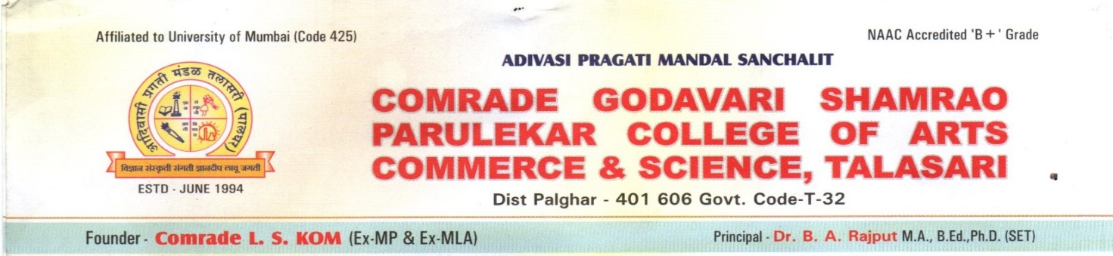
Year | IQAC Minutes & Action Taken Report
2017-18 | http://cgspcollege.org.in/wp-content/uploads/2023/06/IQAC-Minutes-2017-18.pdf
2018-19 | http://cgspcollege.org.in/wp-content/uploads/2021/05/2018-19-1-IQAC-Minutes-20.07.2018.pdf  http://cgspcollege.org.in/wp-content/uploads/2021/05/2018-19-2-IQAC-Minutes-25.08.2018.pdf  http://cgspcollege.org.in/wp-content/uploads/2021/05/2018-19-3-IQAC-Minutes-06.12.2018.pdf  http://cgspcollege.org.in/wp-content/uploads/2021/05/2018-19-4-IQAC-Minutes-13.02.2019.pdf
2019-20 | http://cgspcollege.org.in/wp-content/uploads/2021/05/2019-20-IQAC-Meeting-agenda-and-Minutes.pdf
2020-21 | http://cgspcollege.org.in/wp-content/uploads/2023/06/Minutes-of-IQAC-and-Action-Taken-Report-2020-21.pdf
2021-22 | http://cgspcollege.org.in/wp-content/uploads/2022/12/IQAC-Meeting-agenda-and-Minutes-AND-Action-Taken-Report-2021-22.pdf
2022-23 | http://cgspcollege.org.in/wp-content/uploads/2023/07/IQAC-Minutes-and-Action-Taken-Report-2022-23.pdf

